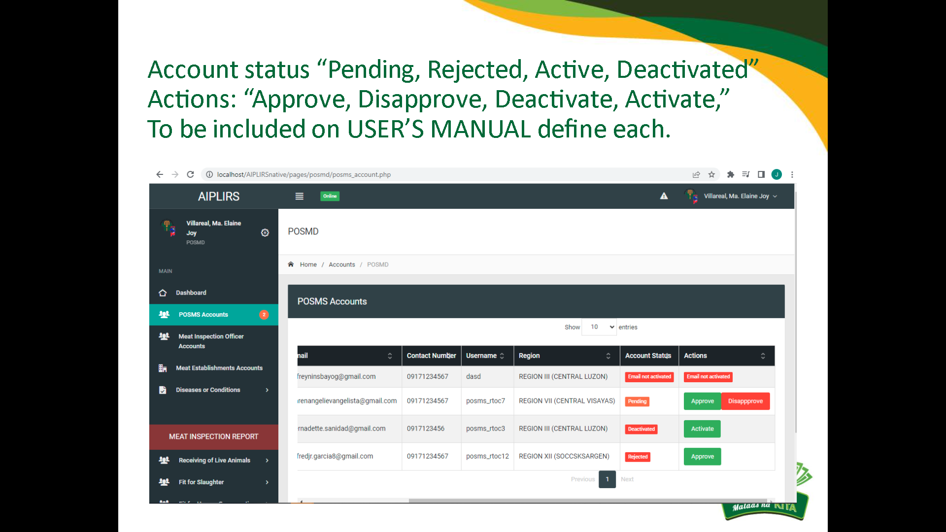

Account status: change “rejected” to “disapproved”

Same with MIO / POSMS accounts

Change reject to disapprove

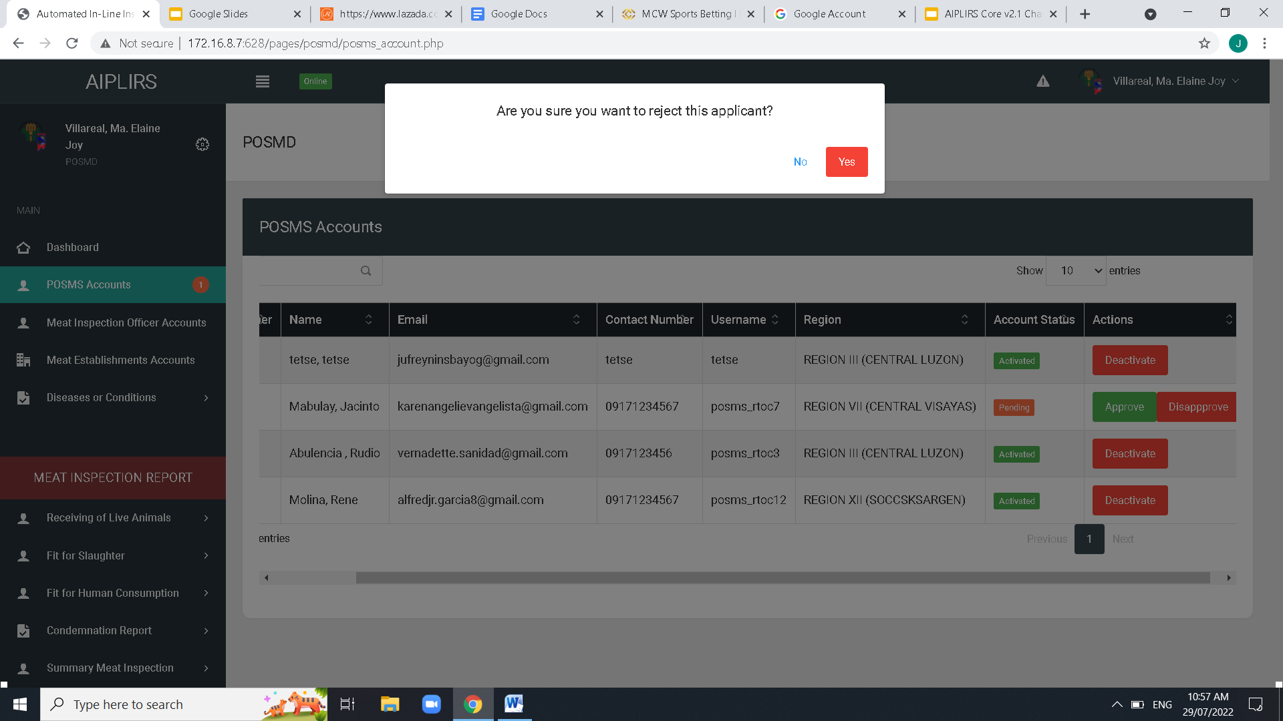

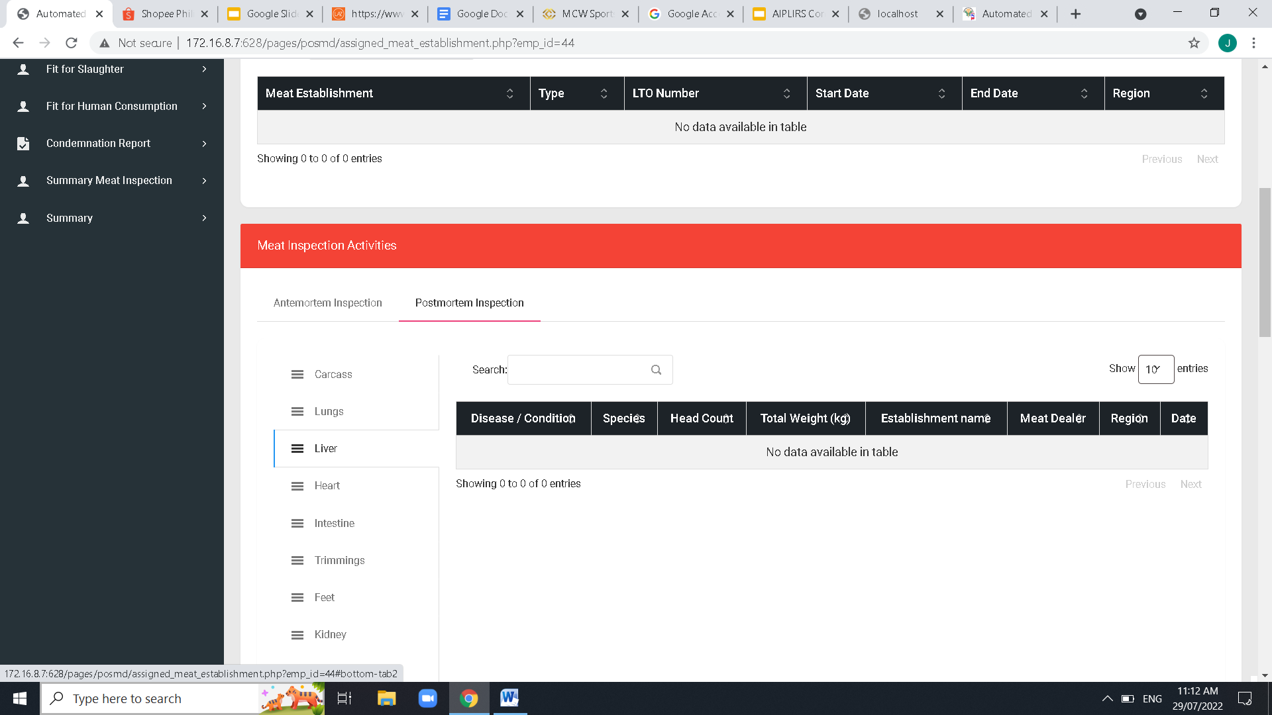

Meat establishment

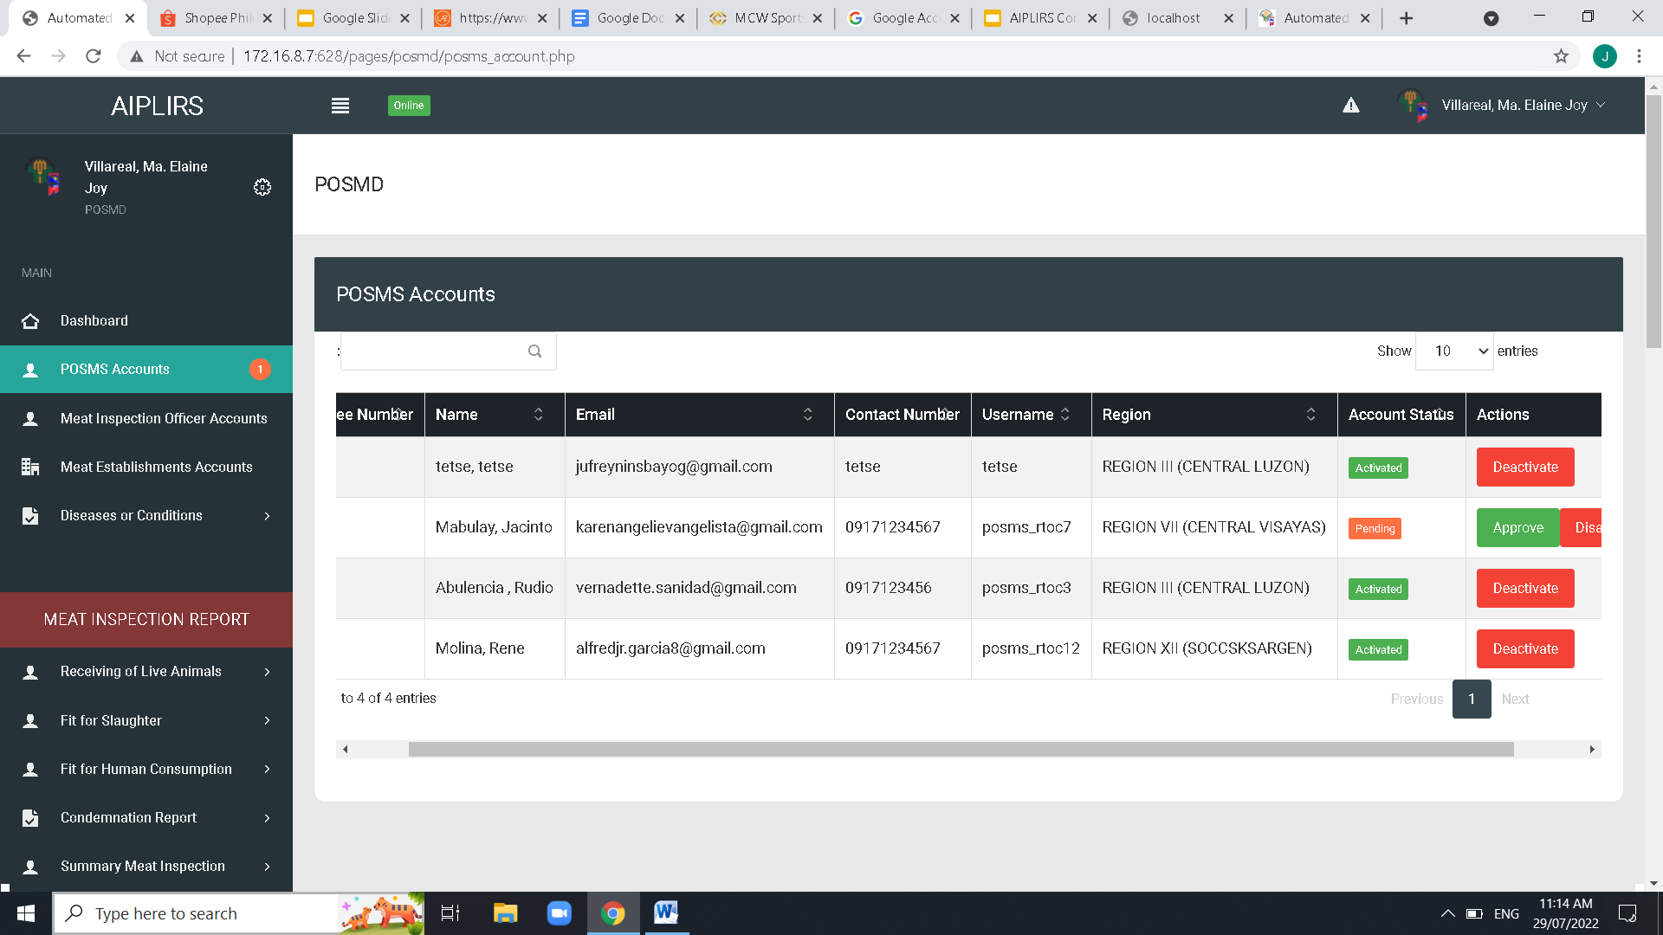

Remove navigaton bar header

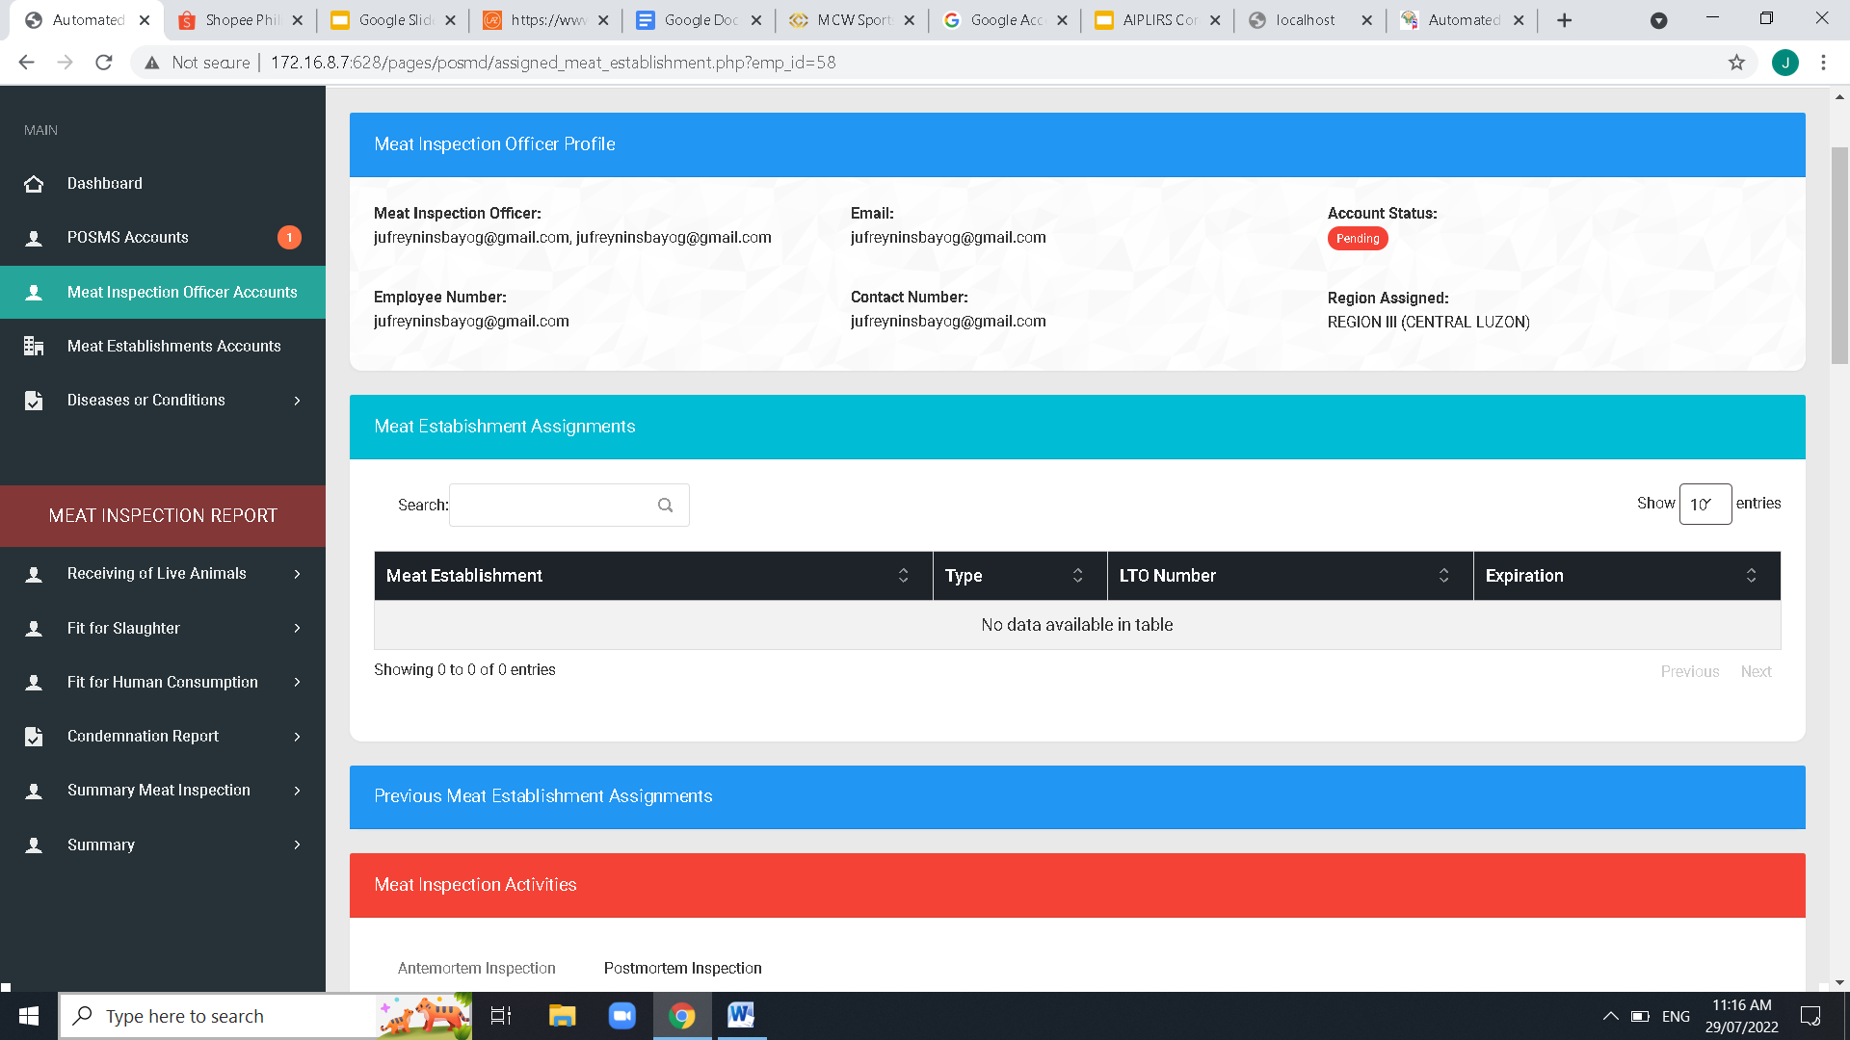

Current Meat Establishment Assigments

No Owner issue

Check database and make it required upon registration

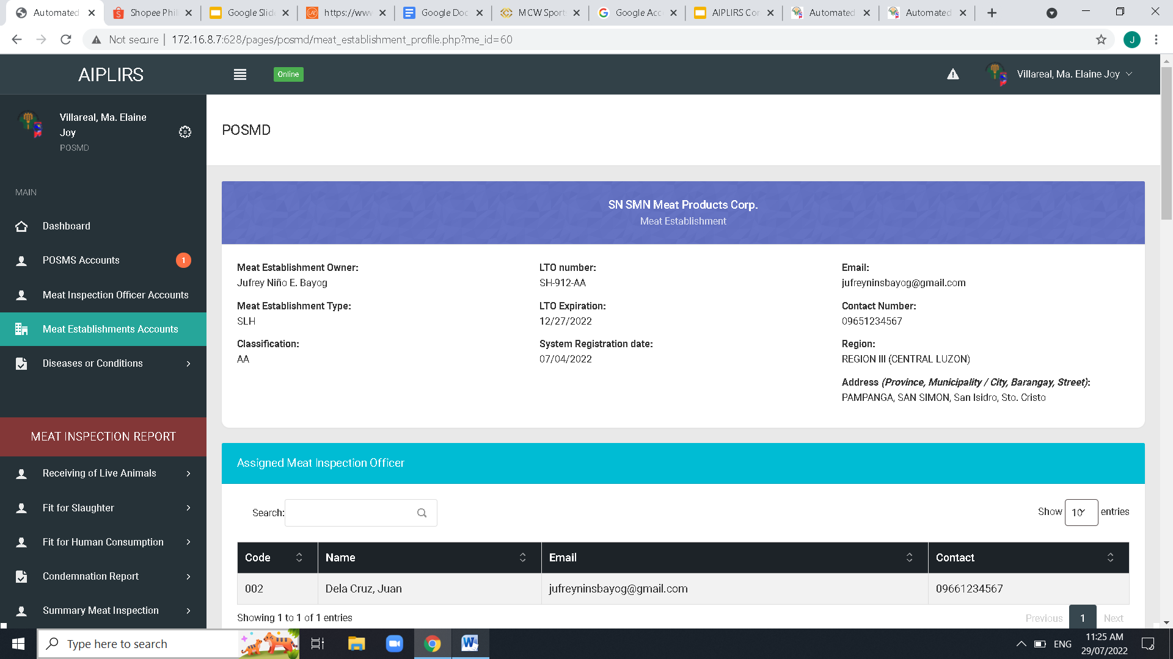

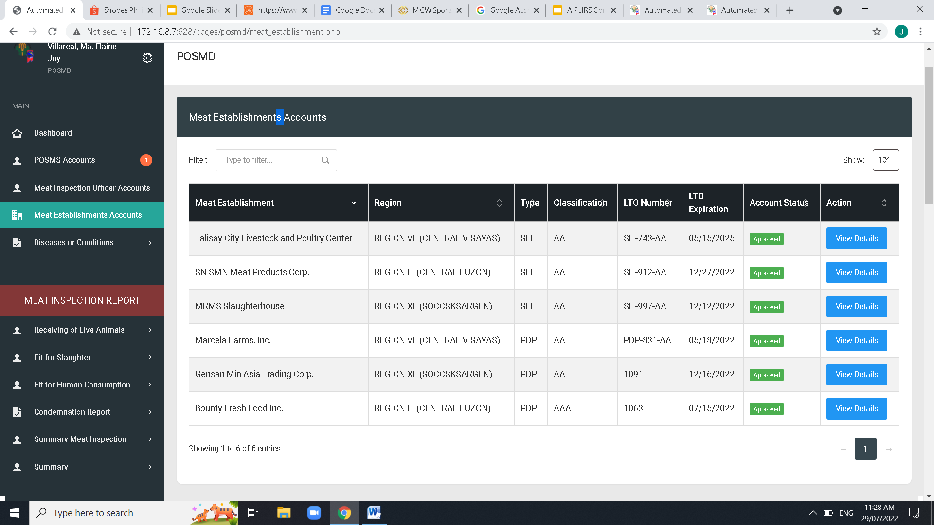

Remove “s” Meat establishments

Remove “s” Meat establishments

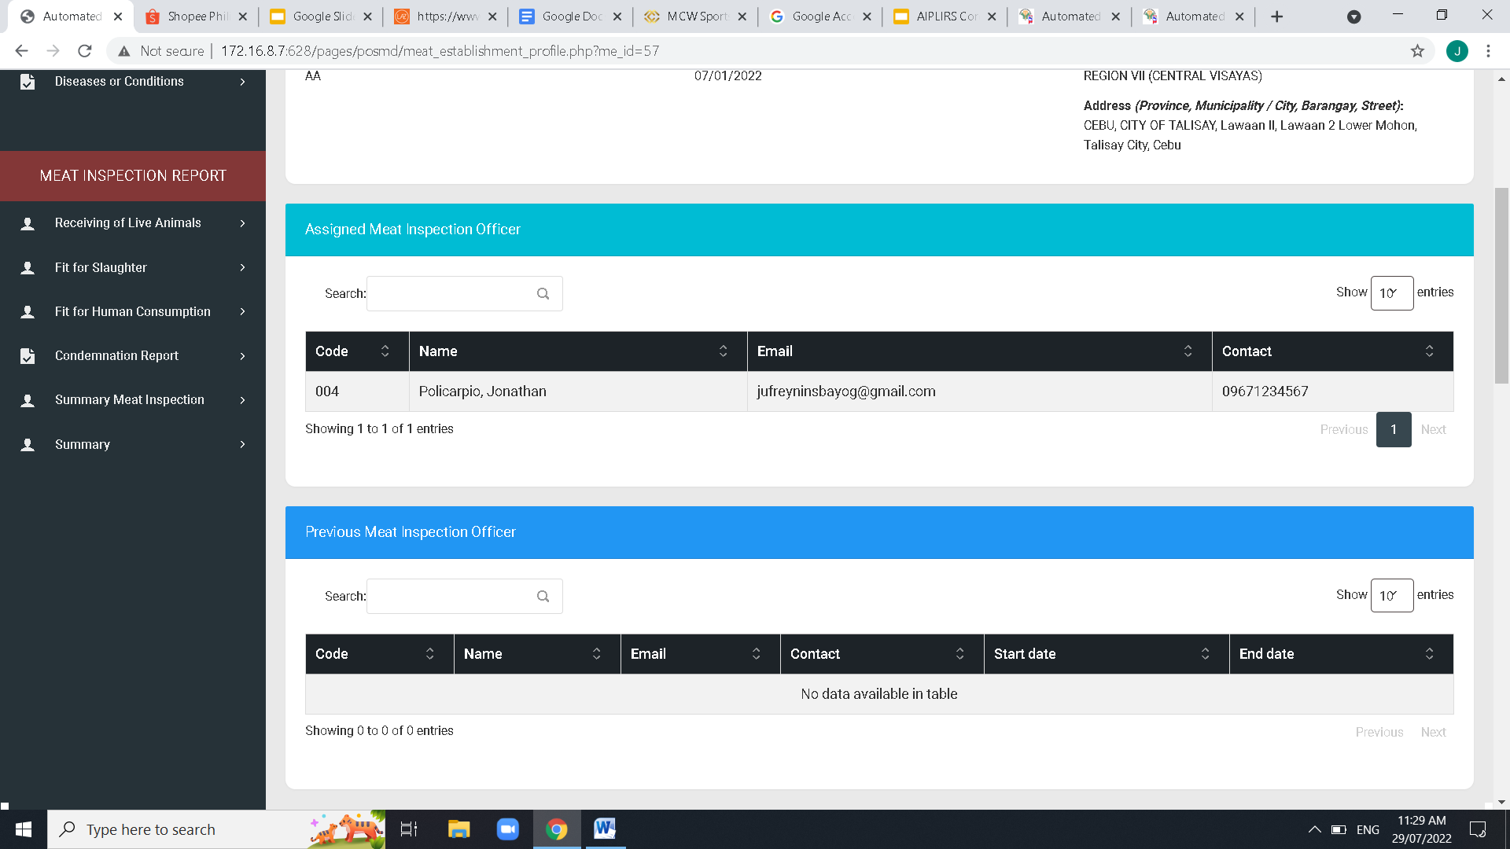

Change to “Previous Meat Inspection Officer Assigned” to Employee number

Change to “Current Meat Inspection Officer Assigned” AND “Code” to Employee number

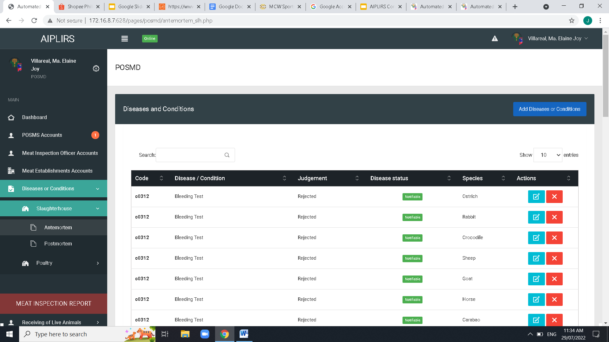

Refer on messenger chat send by doc mej

Remove “s” disease or condition

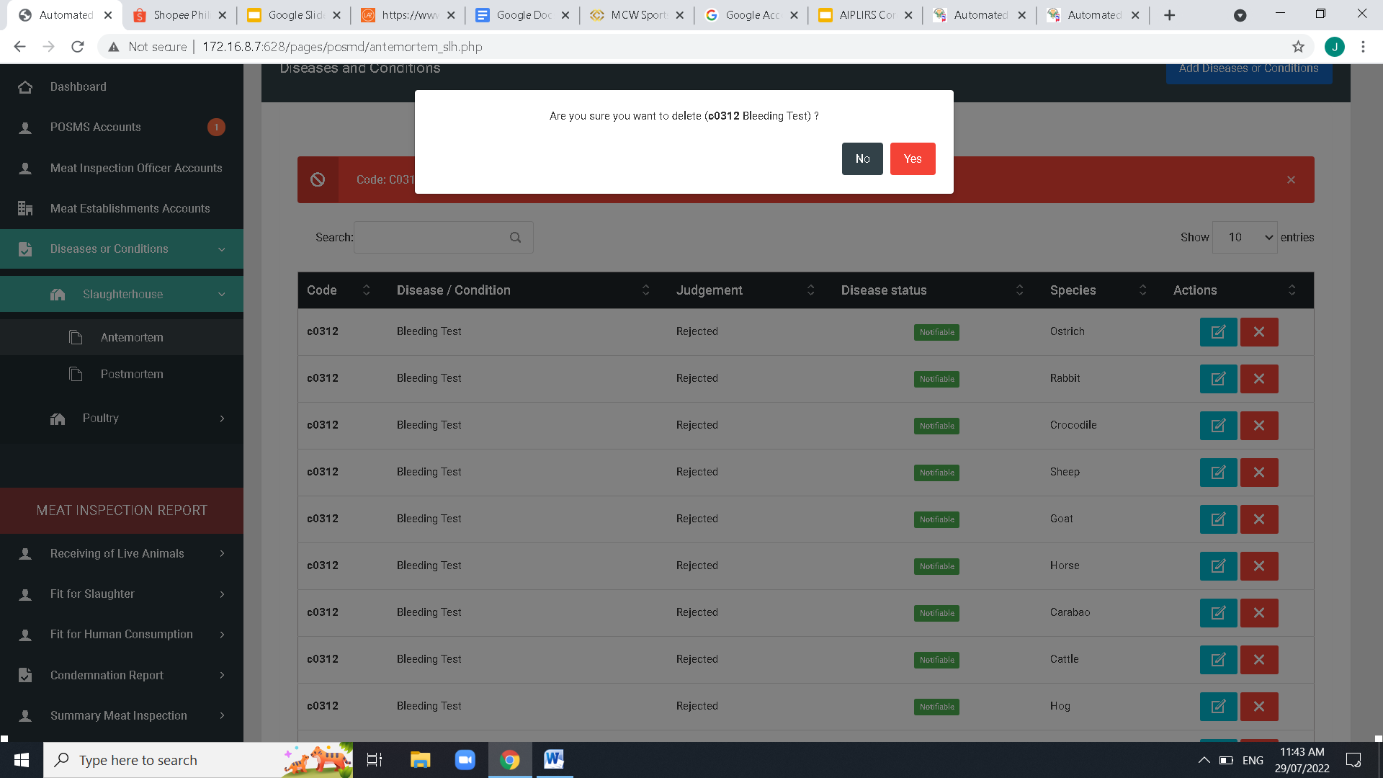

Center button modal

Change button color to Red- No / Green-Yes

TO ALL POP UP QUESTION

Change Font size into a readable size

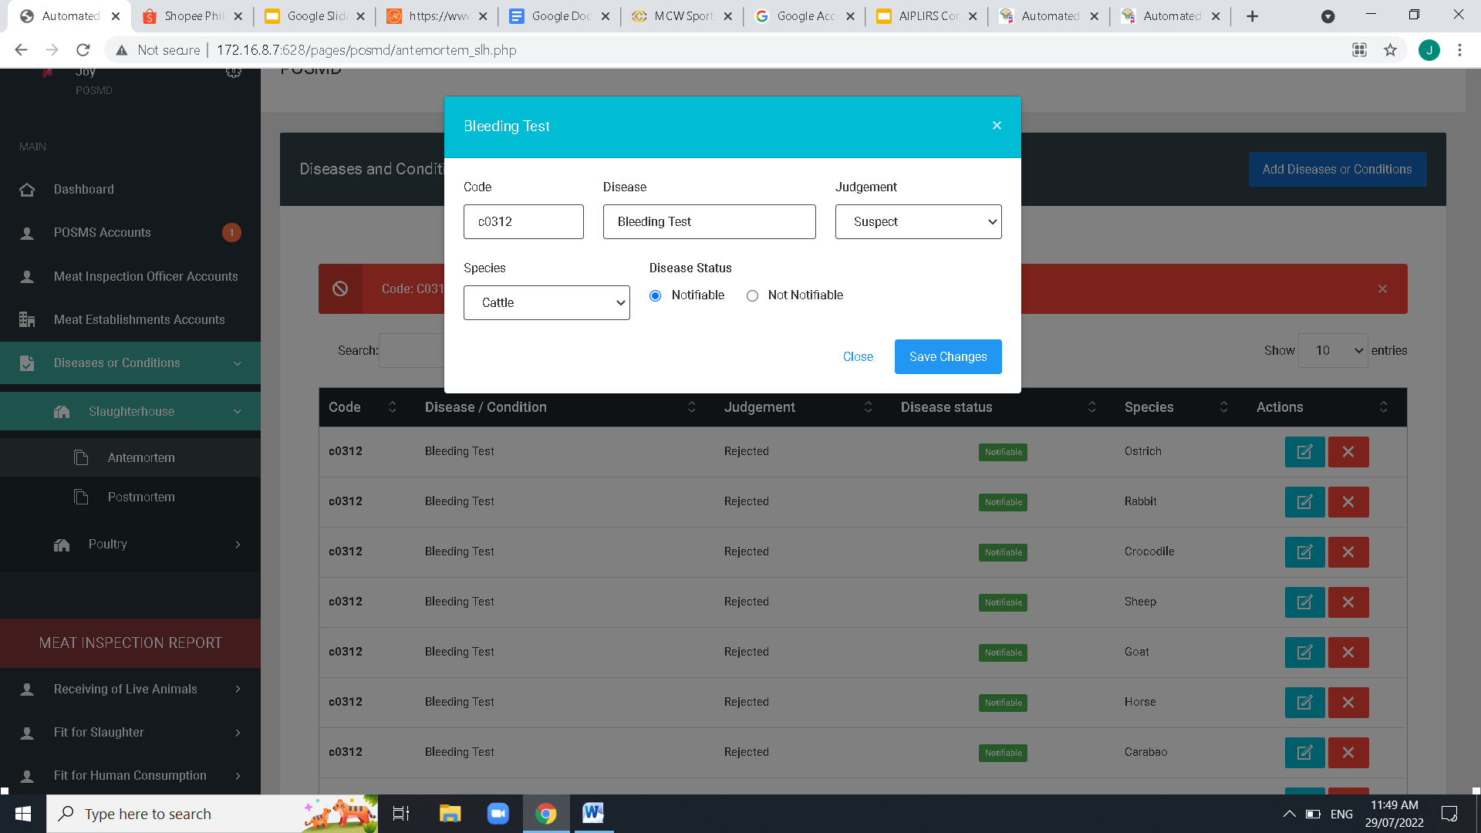

For Monday Multiple species to be edit if not existed insert on database

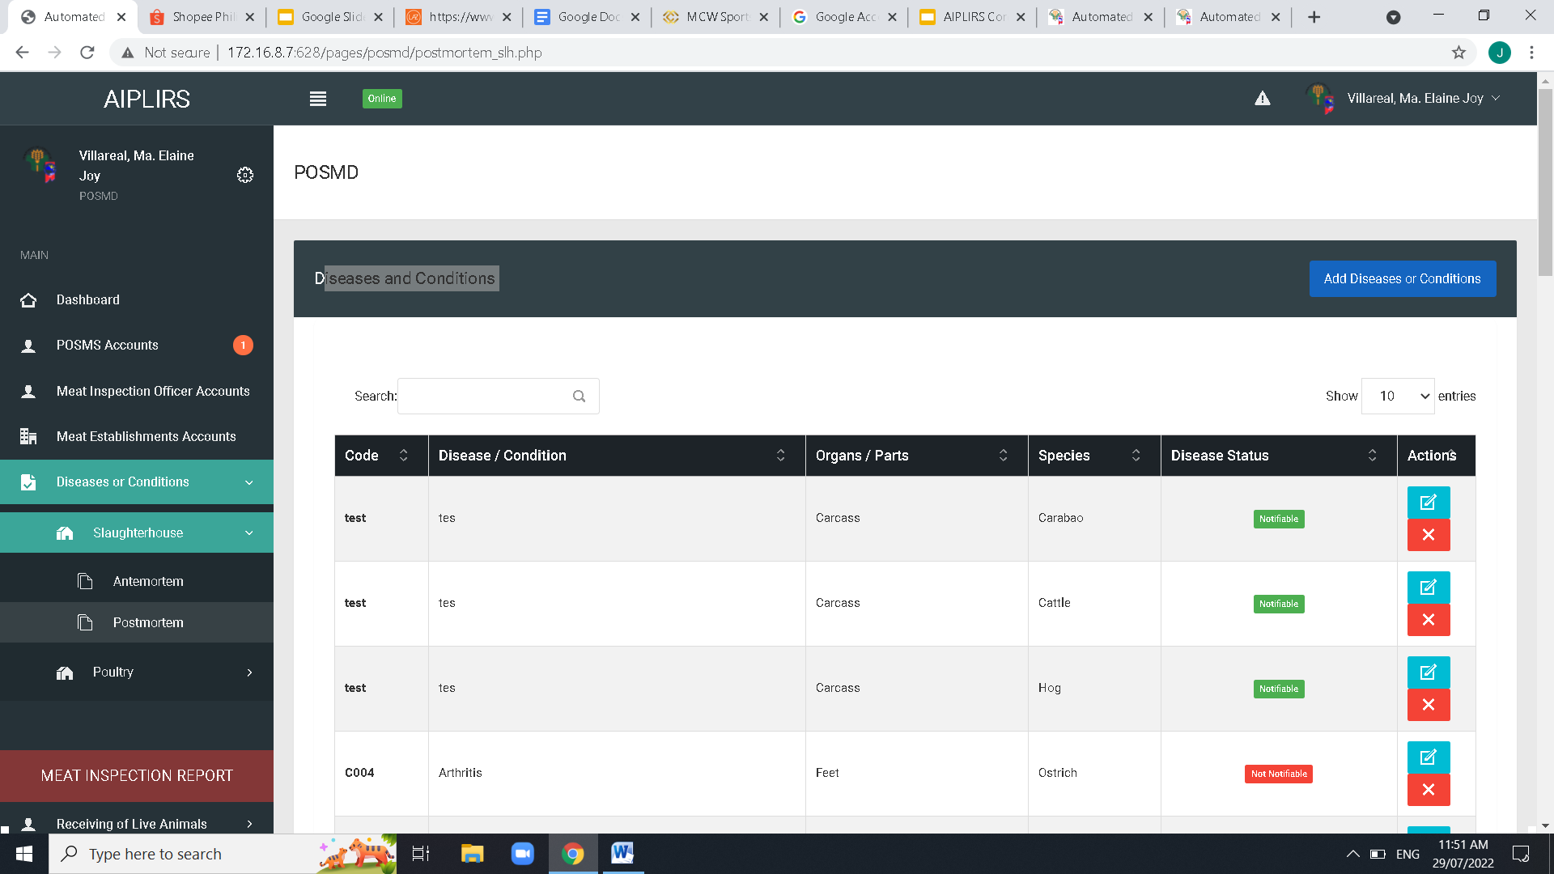

Same issue on SLH antemortem ispection

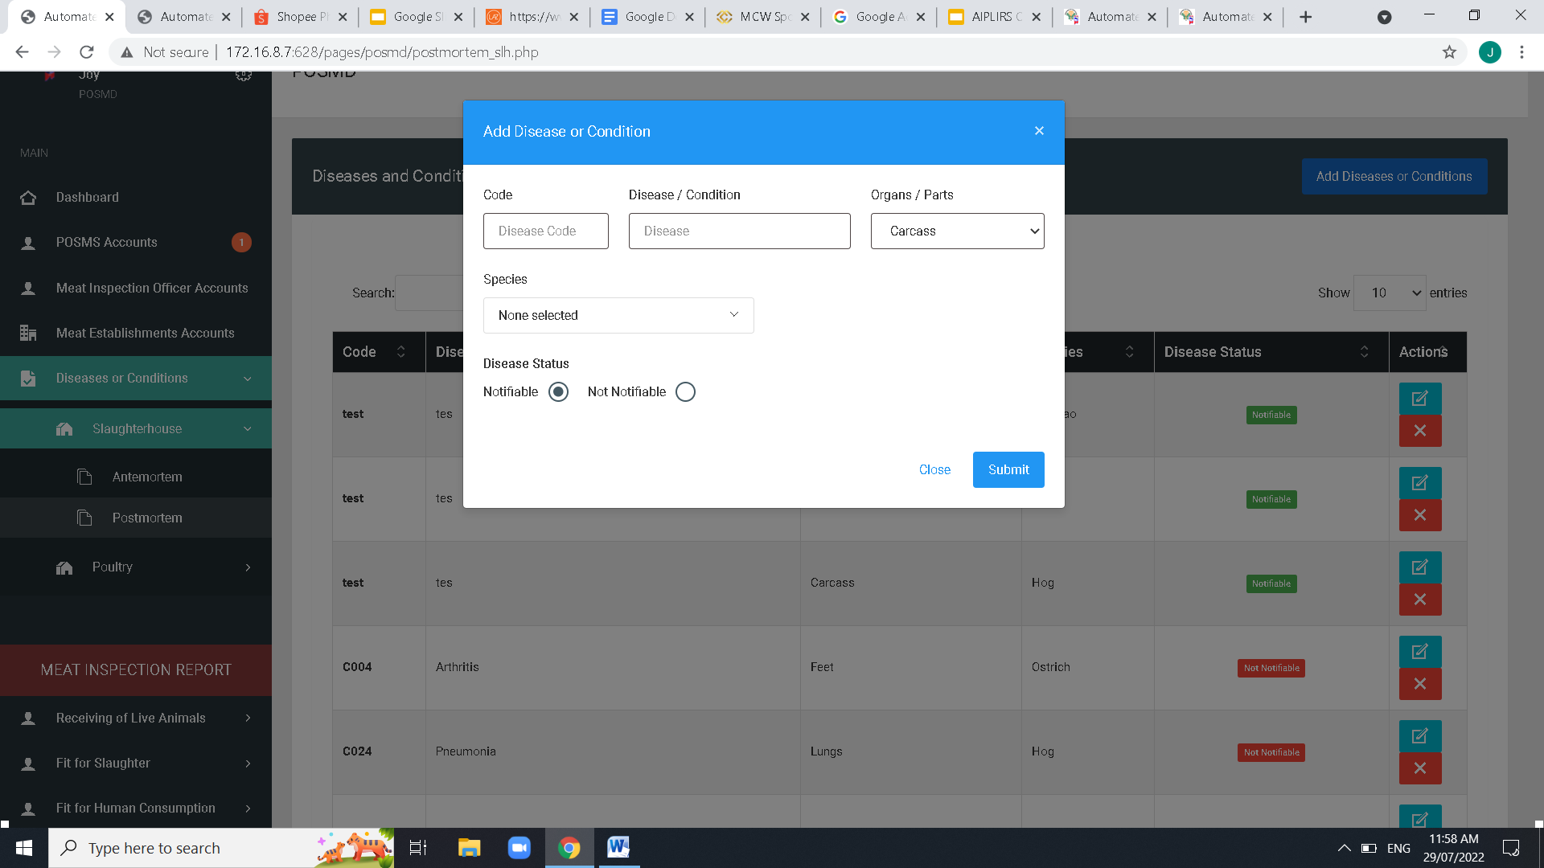

before species dropdown add judgement dropdown

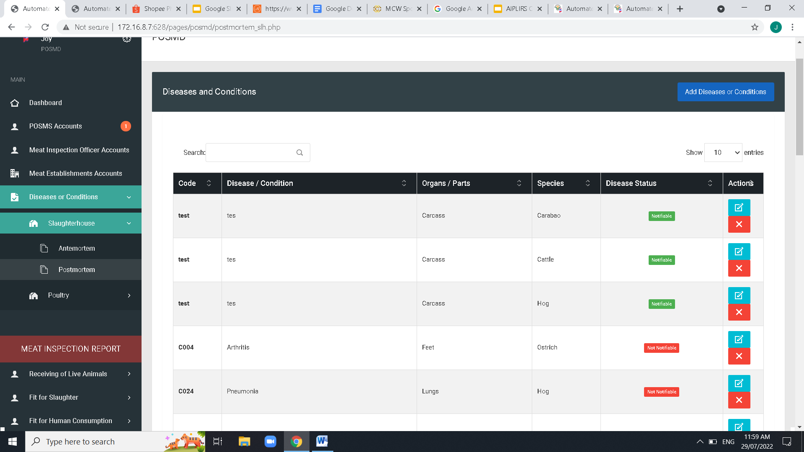

Table Column order: Code - Disease / Condition – Judgement – Organs/Parts – Species- Disease Status-ACTIONS and Spacing of Table data

Center button modal

Change button color to Red- No / Green-Yes

TO ALL POP UP QUESTION

Change Font size into a readable size

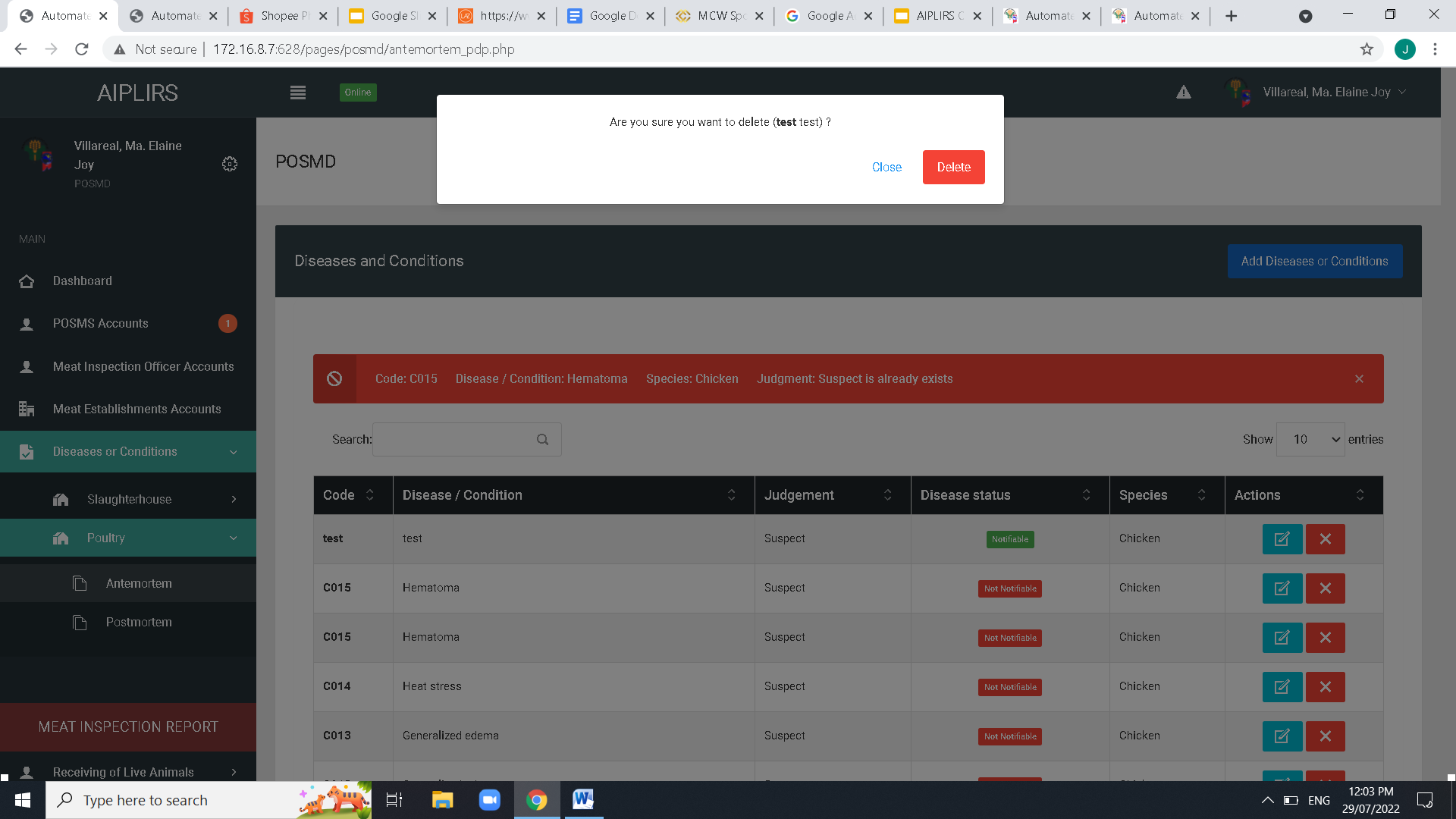

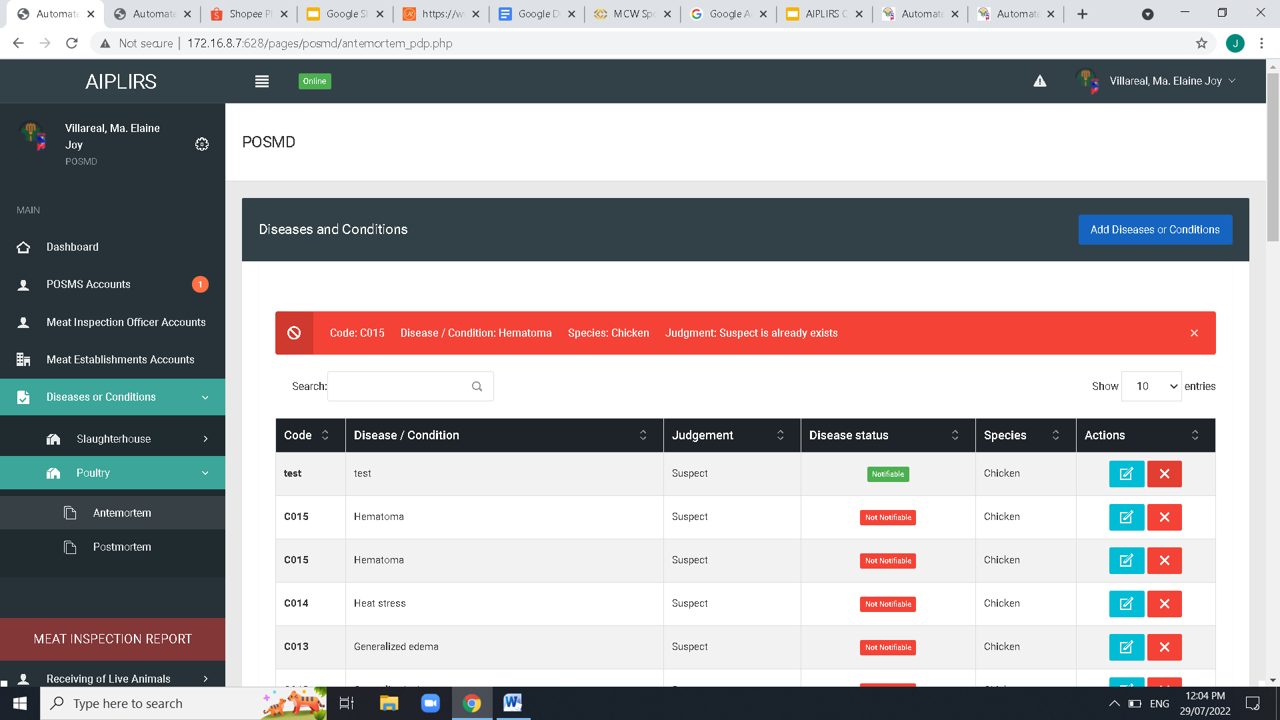

SIDEBAR label: poultry change to Poultry Dressing Plant

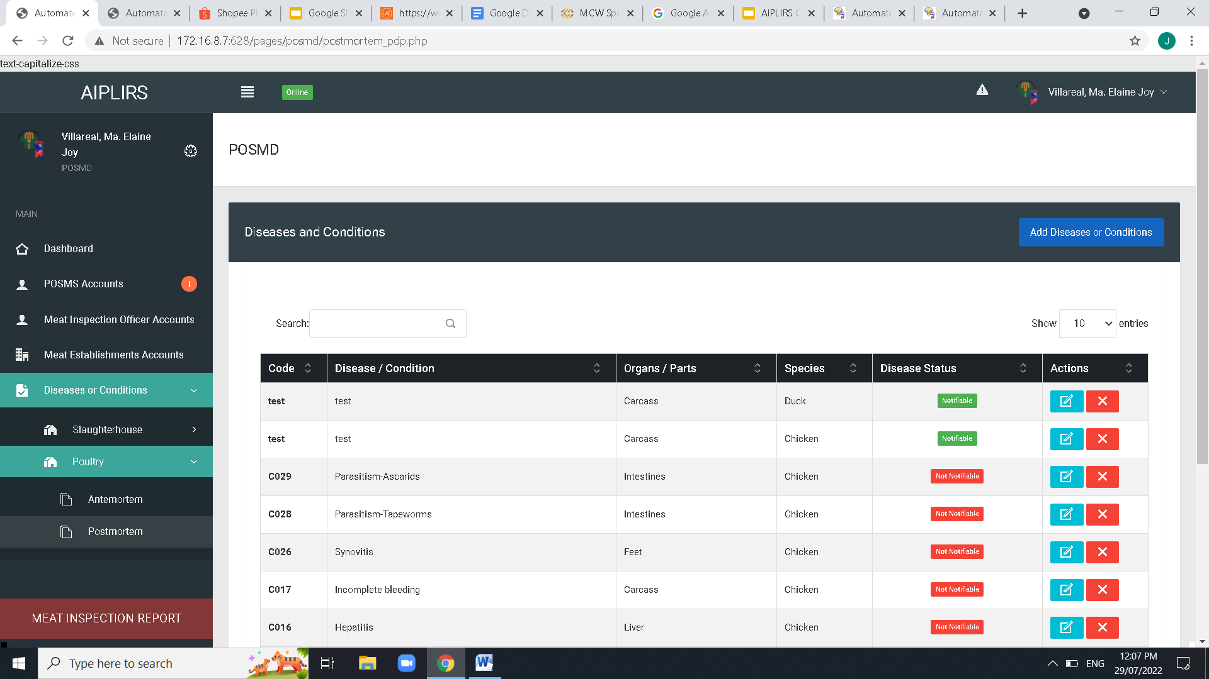

Table Column order: Code - Disease / Condition – Judgement – Organs/Parts – Species- Disease Status-ACTIONS and Spacing of Table data

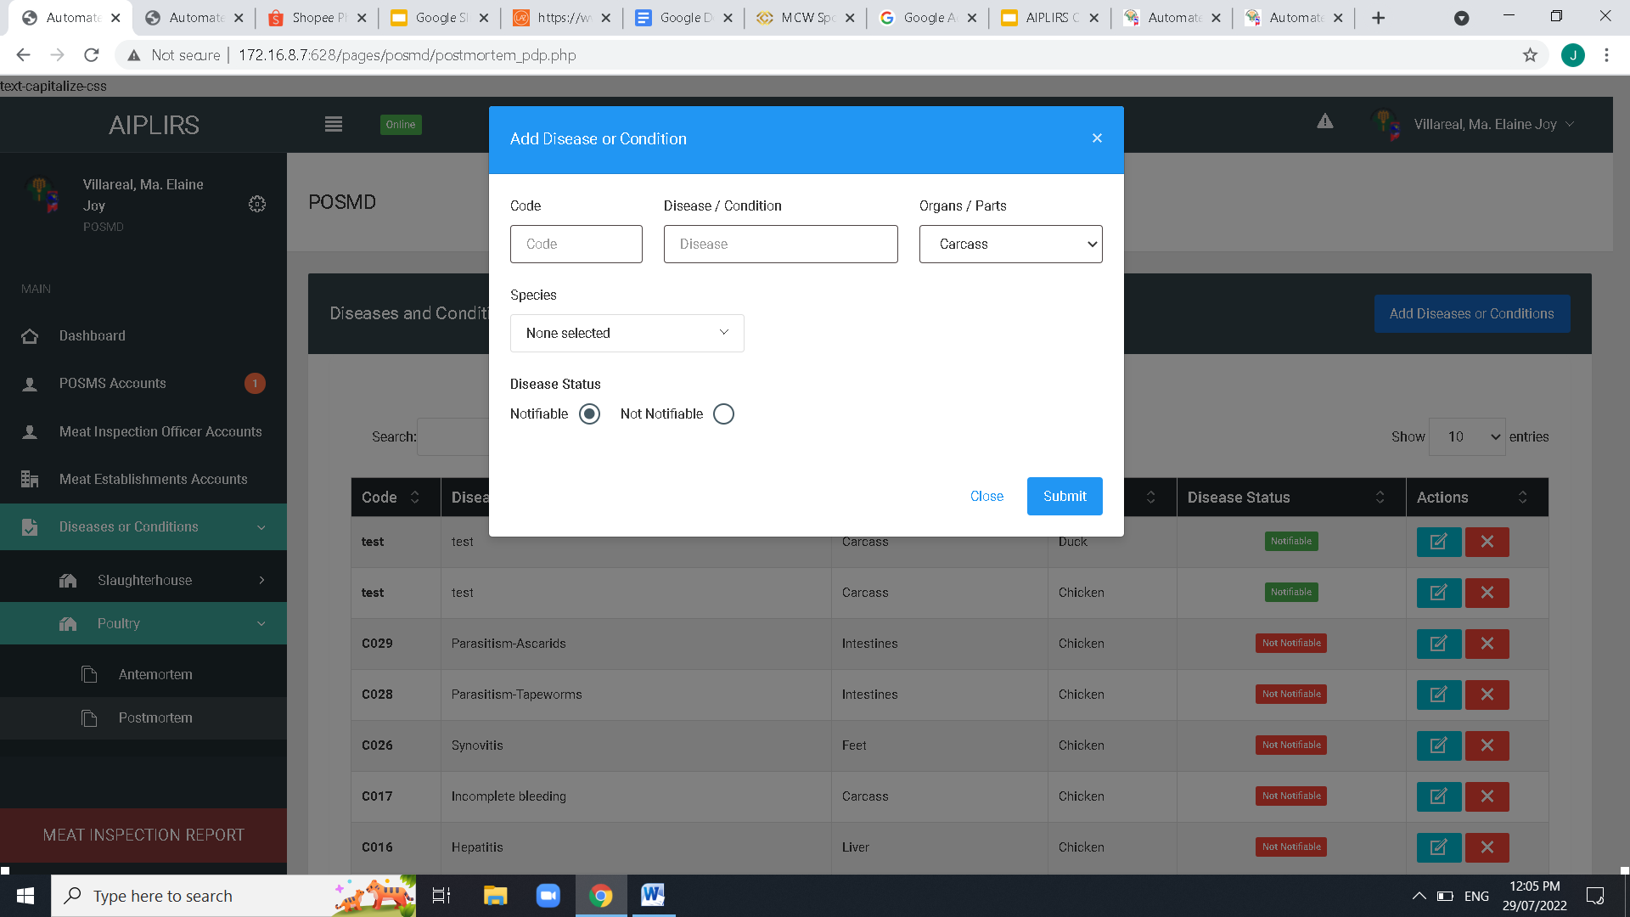

Add judgement dropdown before species

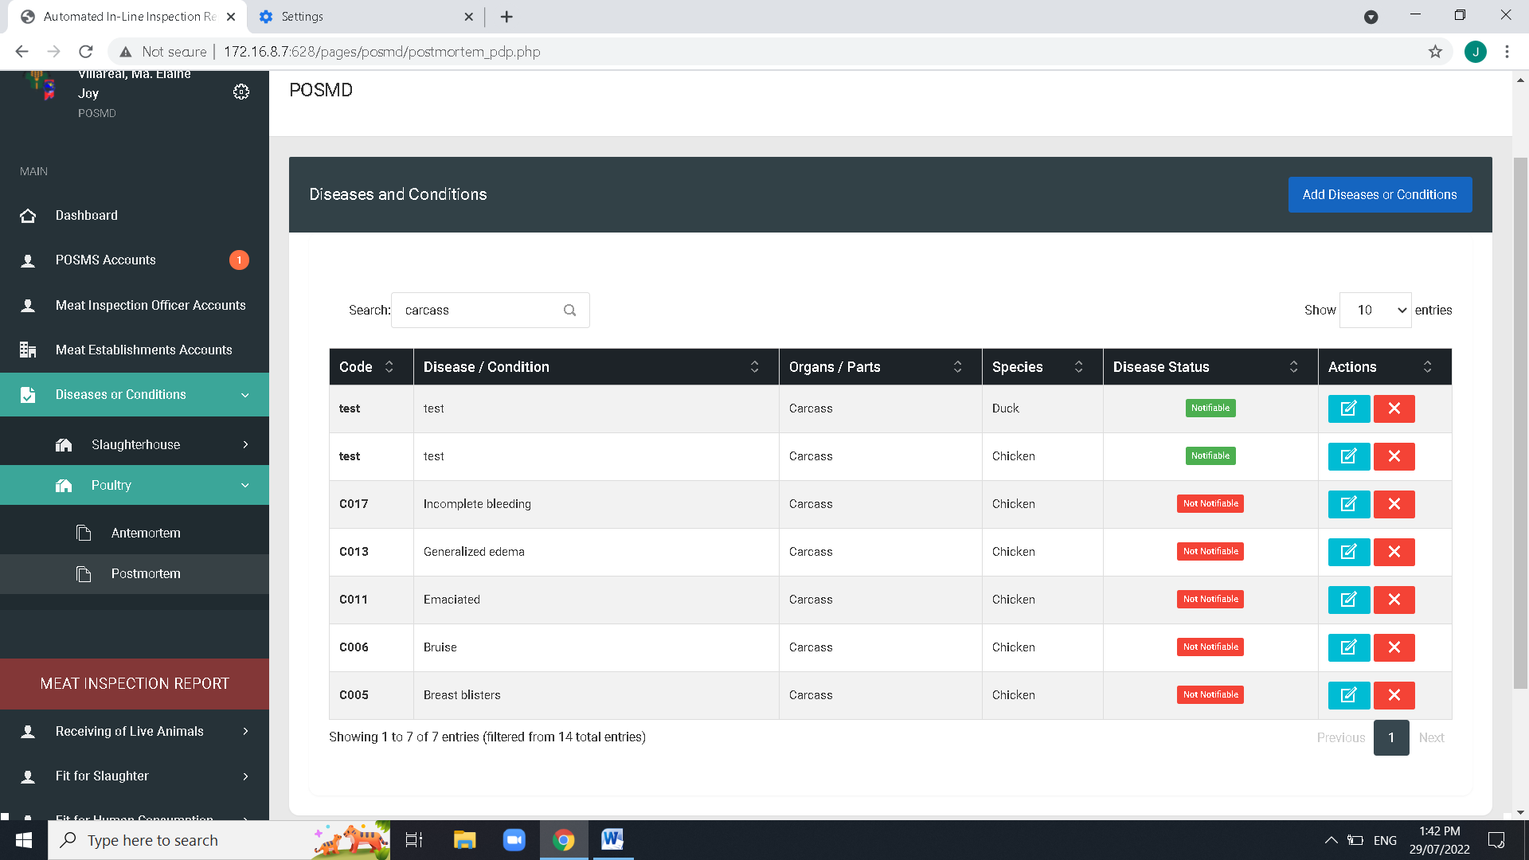

Create a dropdown filtering of each column on disease and condition and the order of the dropdown similar with the table header

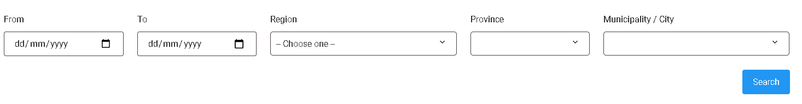

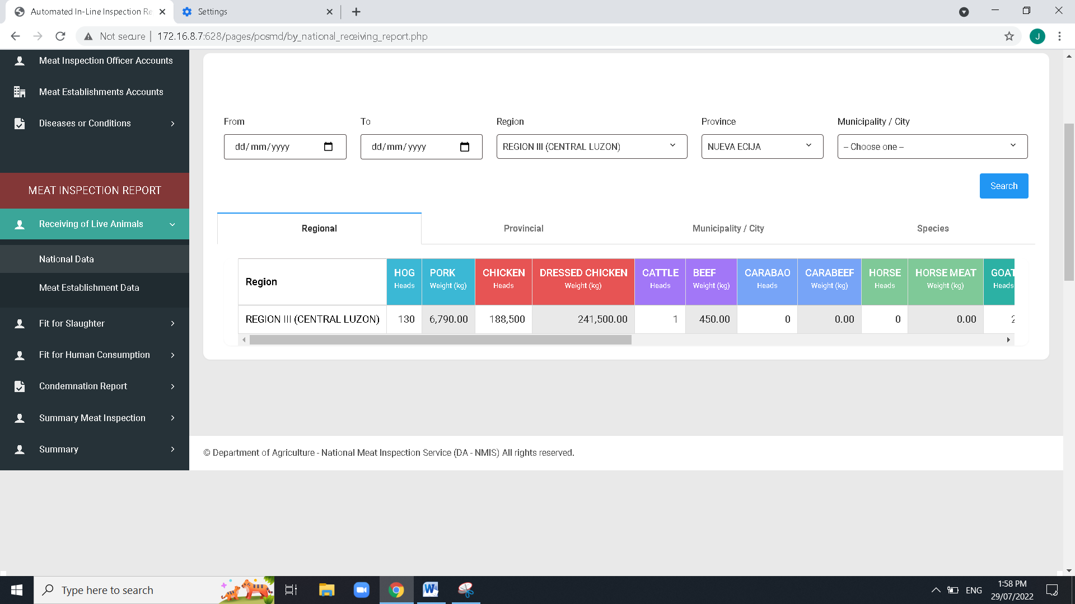

On the top of the table add table for the total all Meat inspection report of receiving,slaughter, fit for human consumption

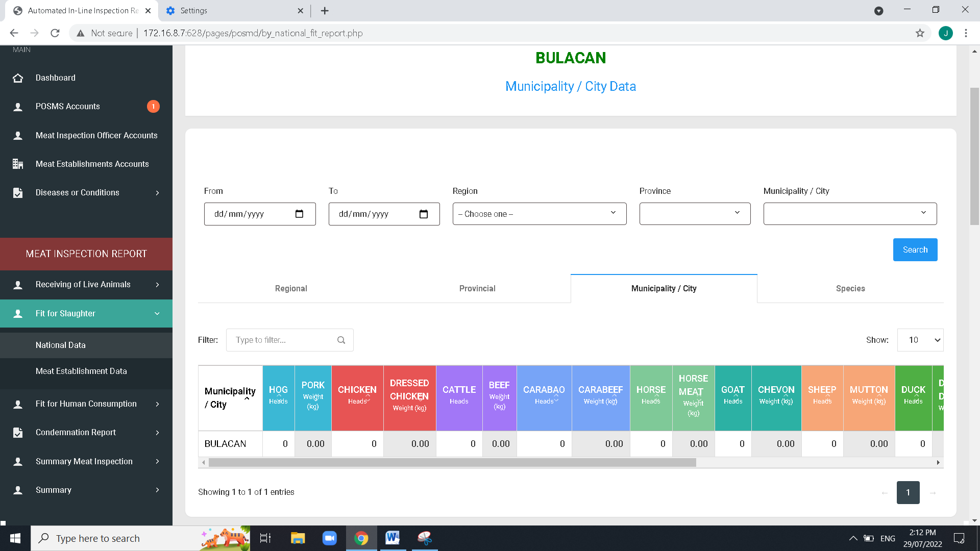

Missing Data.. check the code row on line 11,900+ for the fetching and addition of data

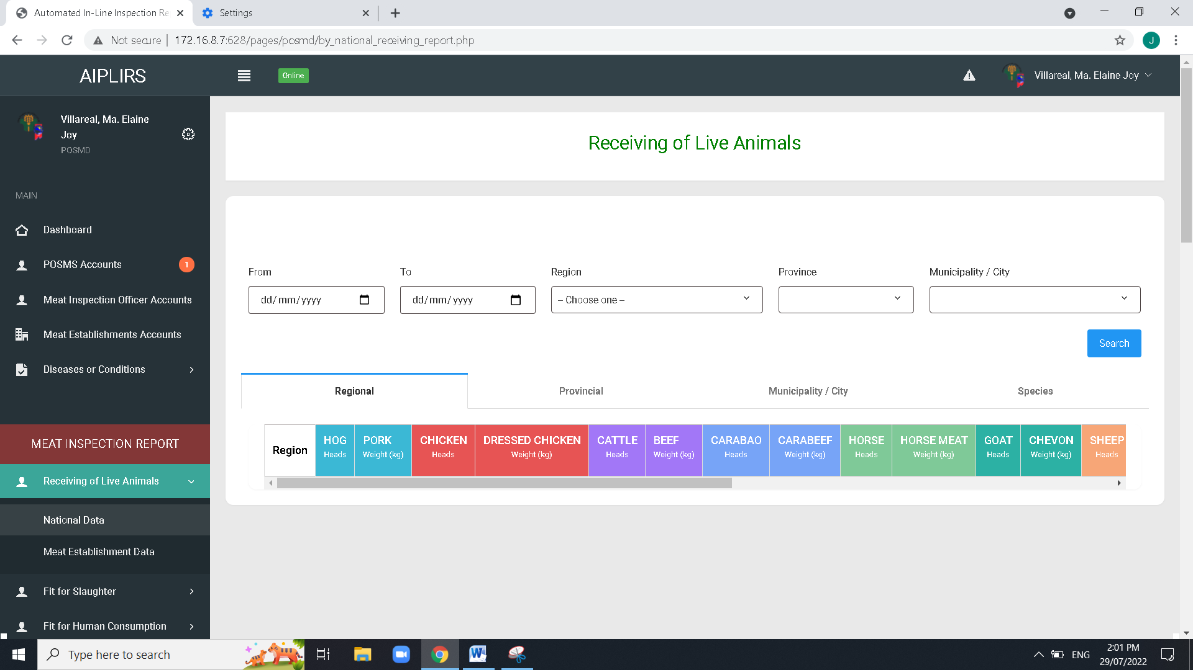

Remove “LIVE” on the sidebar label

Remove “LIVE” on the header title

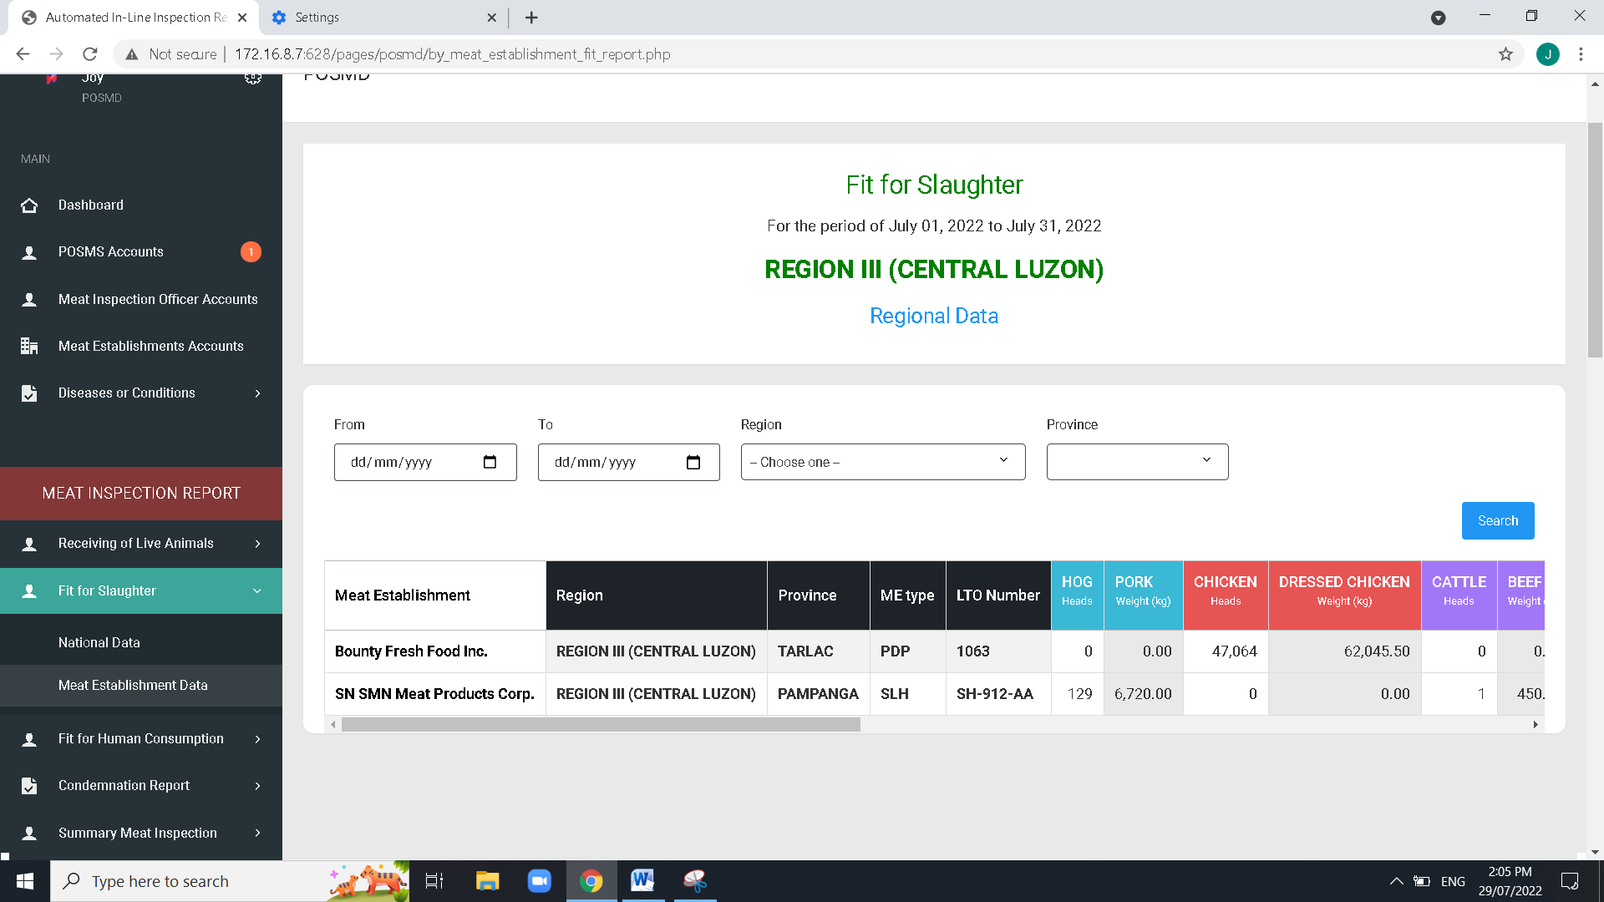

Remove column Region in all summary of meat establishment

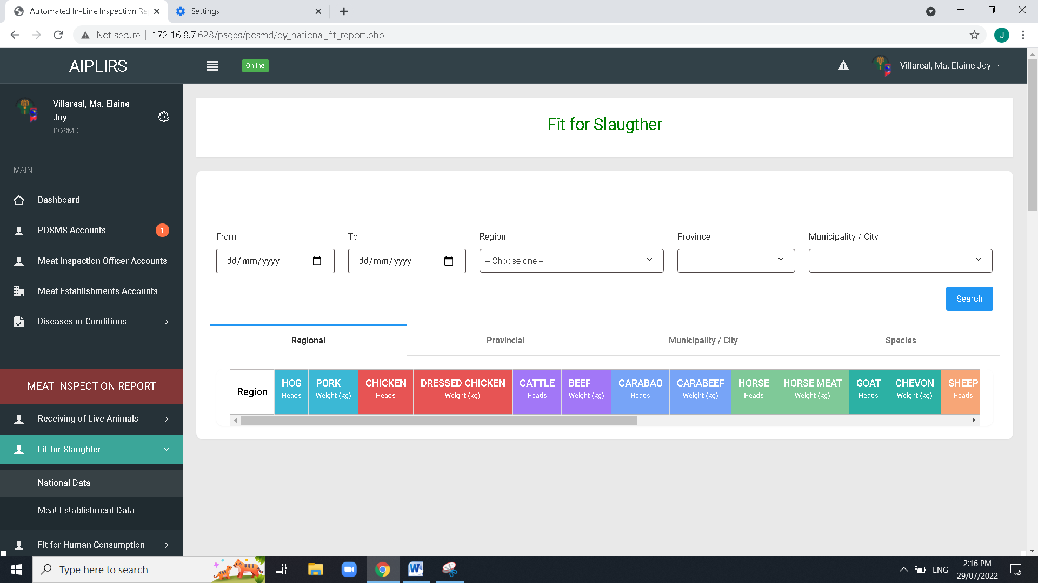

Spelling ”slaughter”

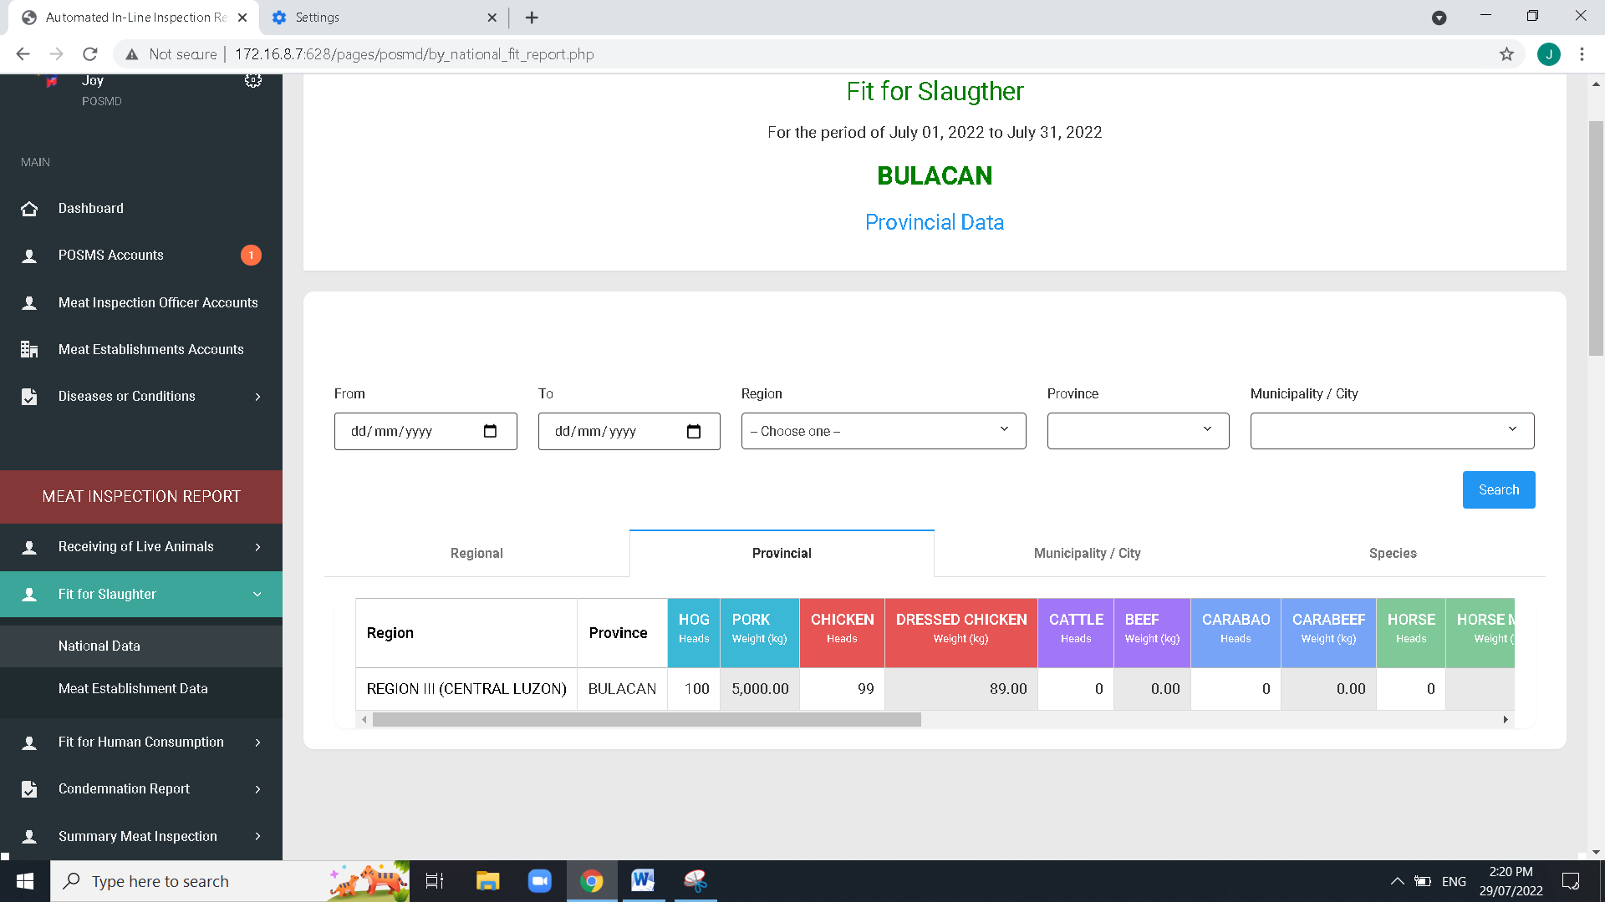

Remove Title. Regional, province, city, national

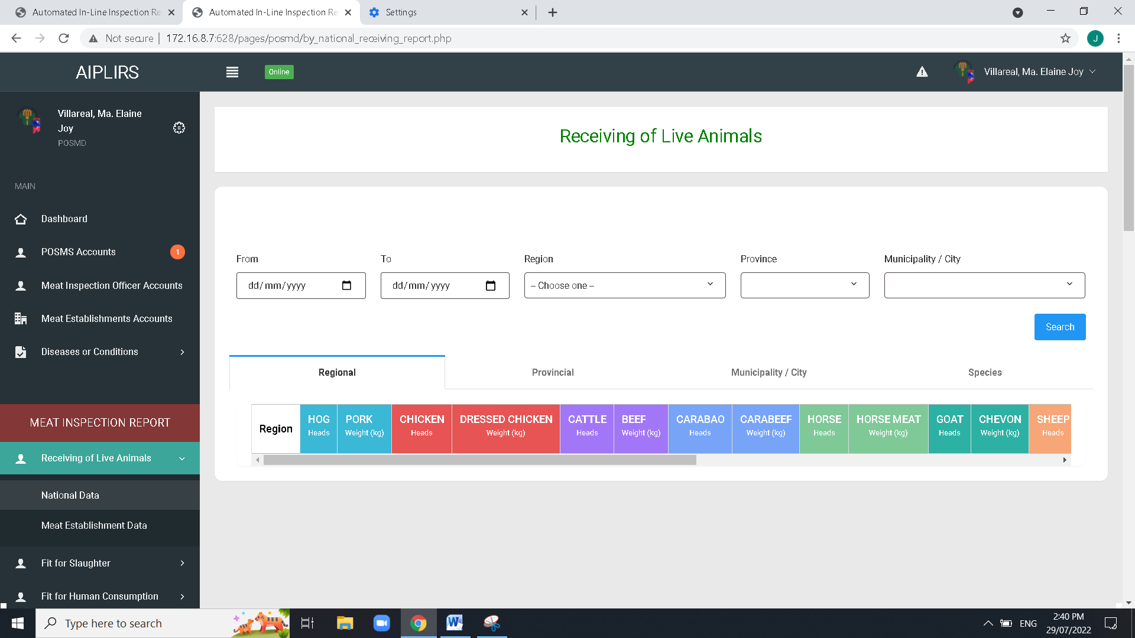

Remove tabs and leave tab for species… in all reports (Receiving, Fit for Slaughter, Fit for human Consumption)

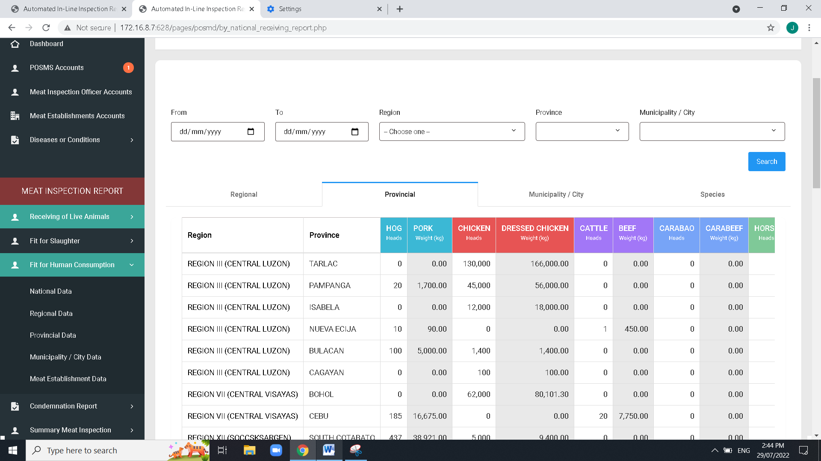

Fit for human consumption for next patch developed in localhost uploaded in GITHUB pull origin in date july 23, 2022

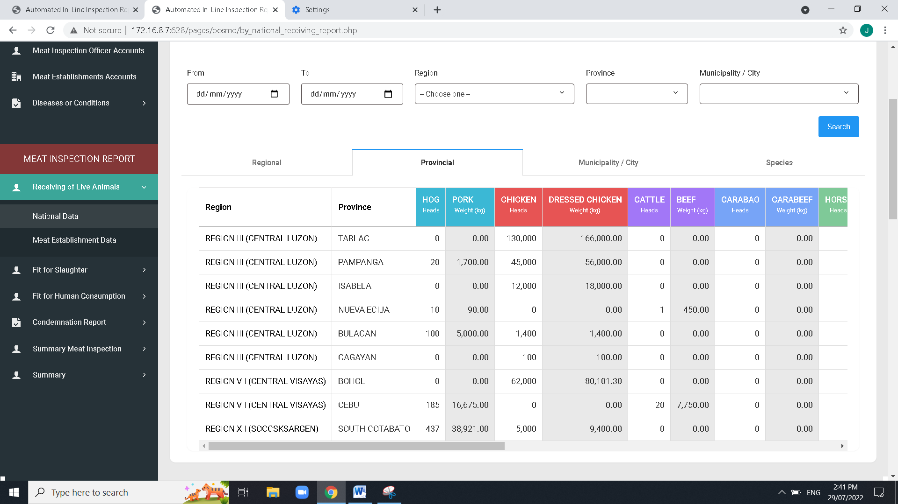

Add column for the Municipality / City in all repots (Receiving, Fit for slaughter, Fit for human consumption)

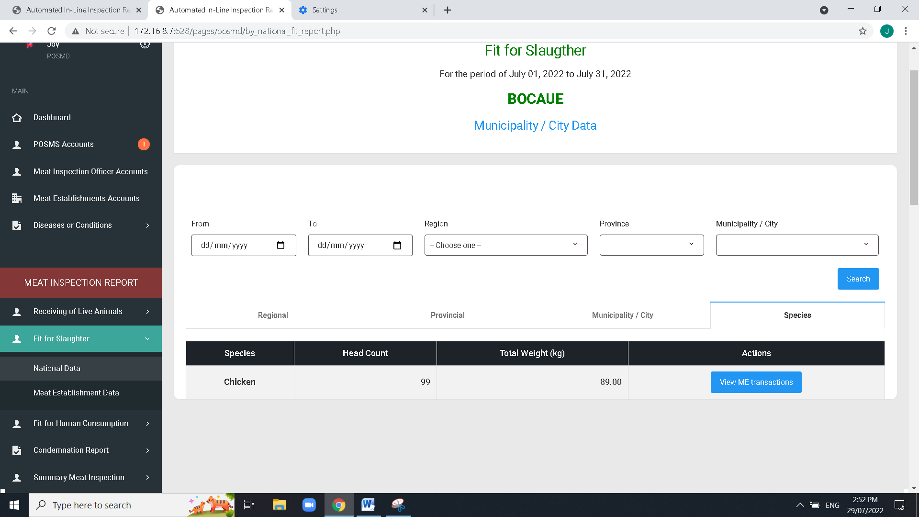

Apply this title for the addition column table column below.

Additional column:National data / Regional, Provincial, muni /city/ based on the filter fields above

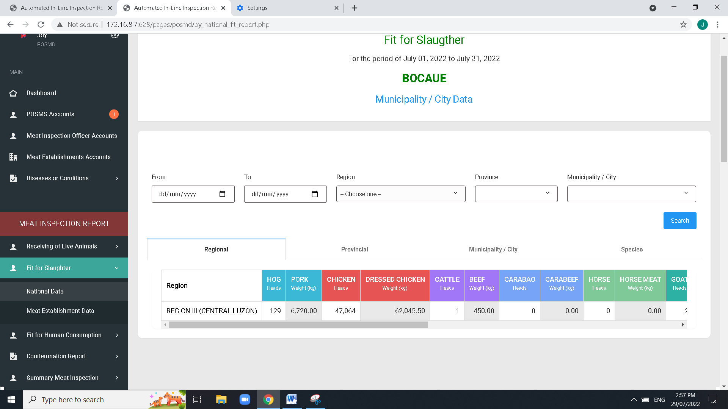

Change horizontal tab title:

Regional to location

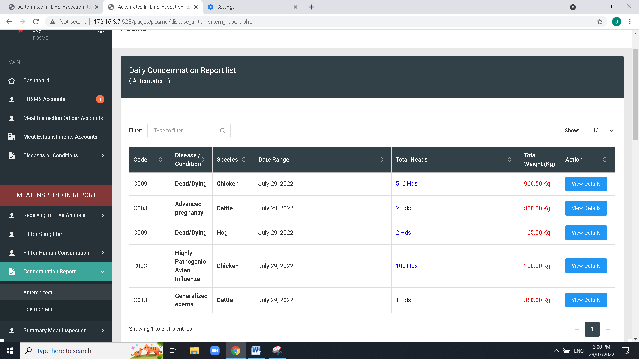

Date range to date

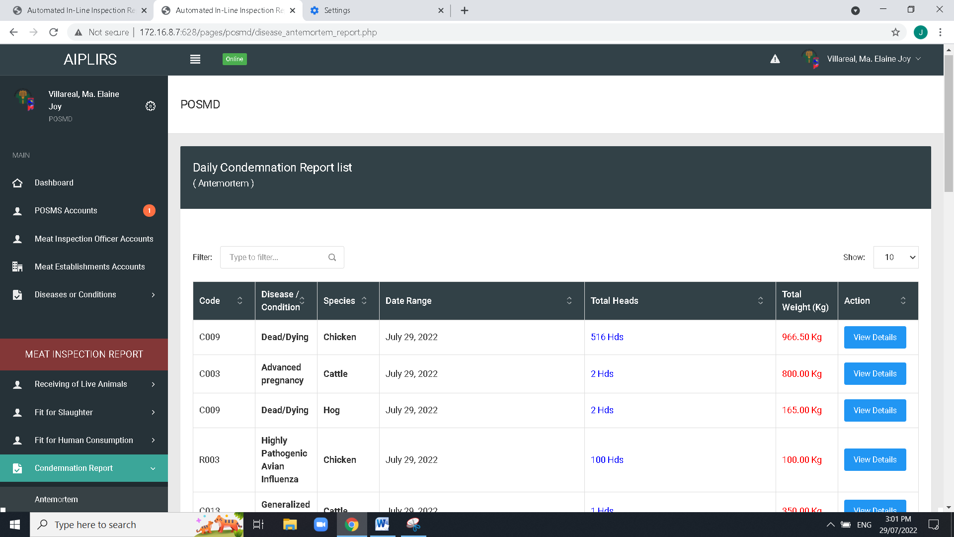

Change to “Ante-mortem Condemnation Report”

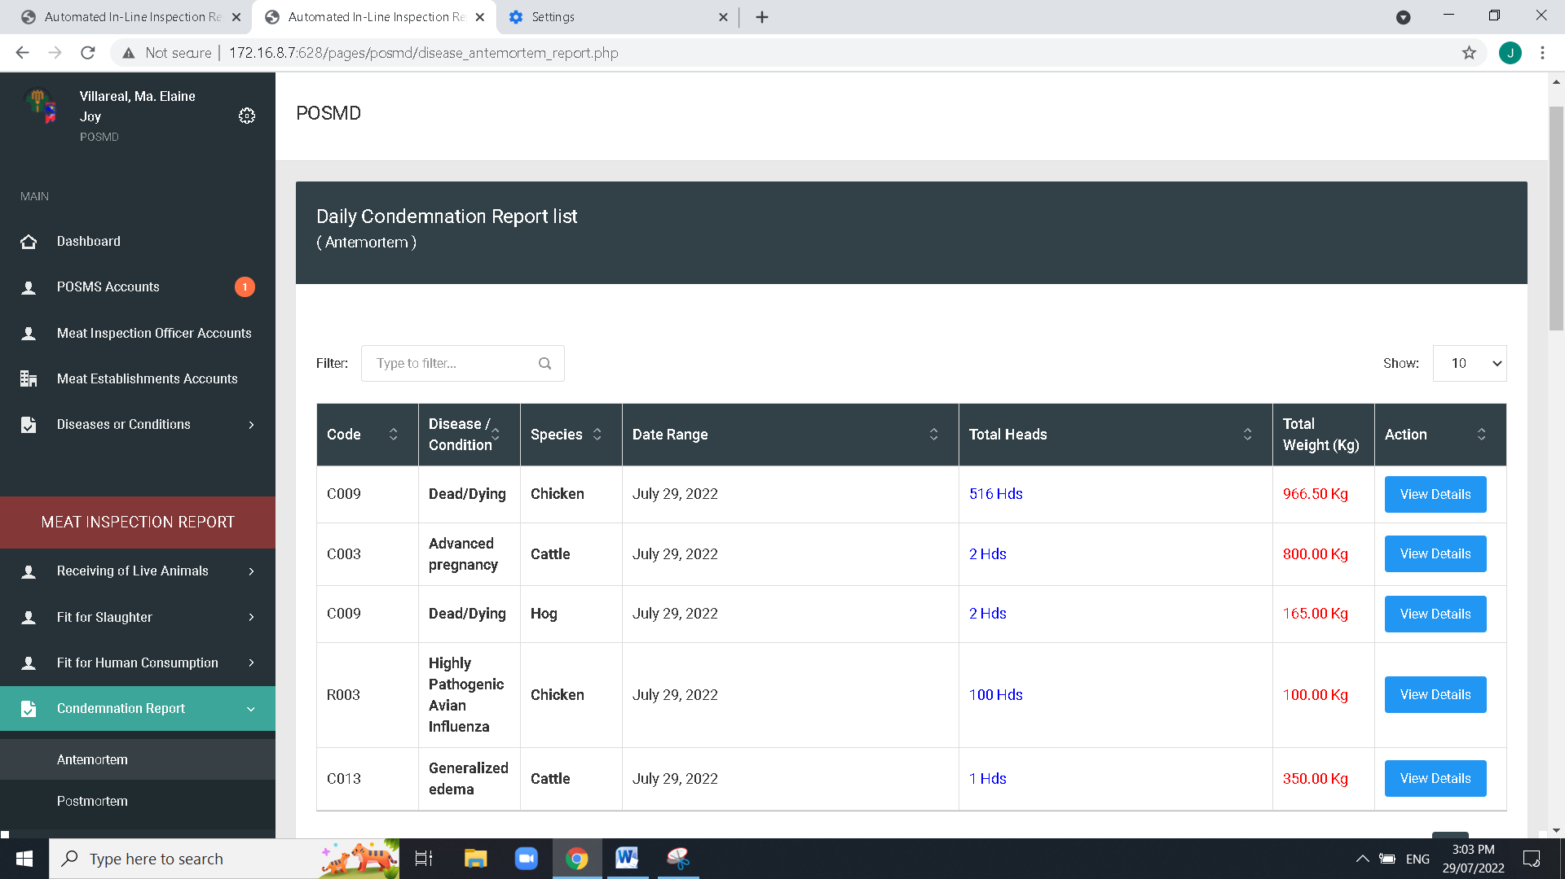

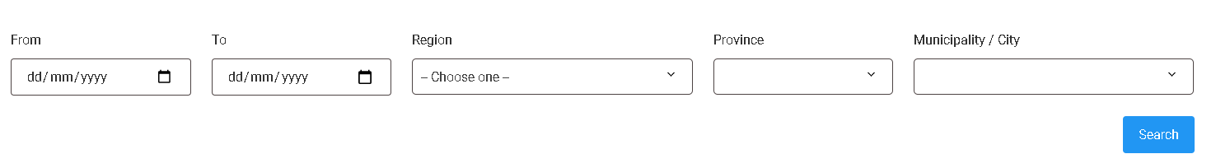

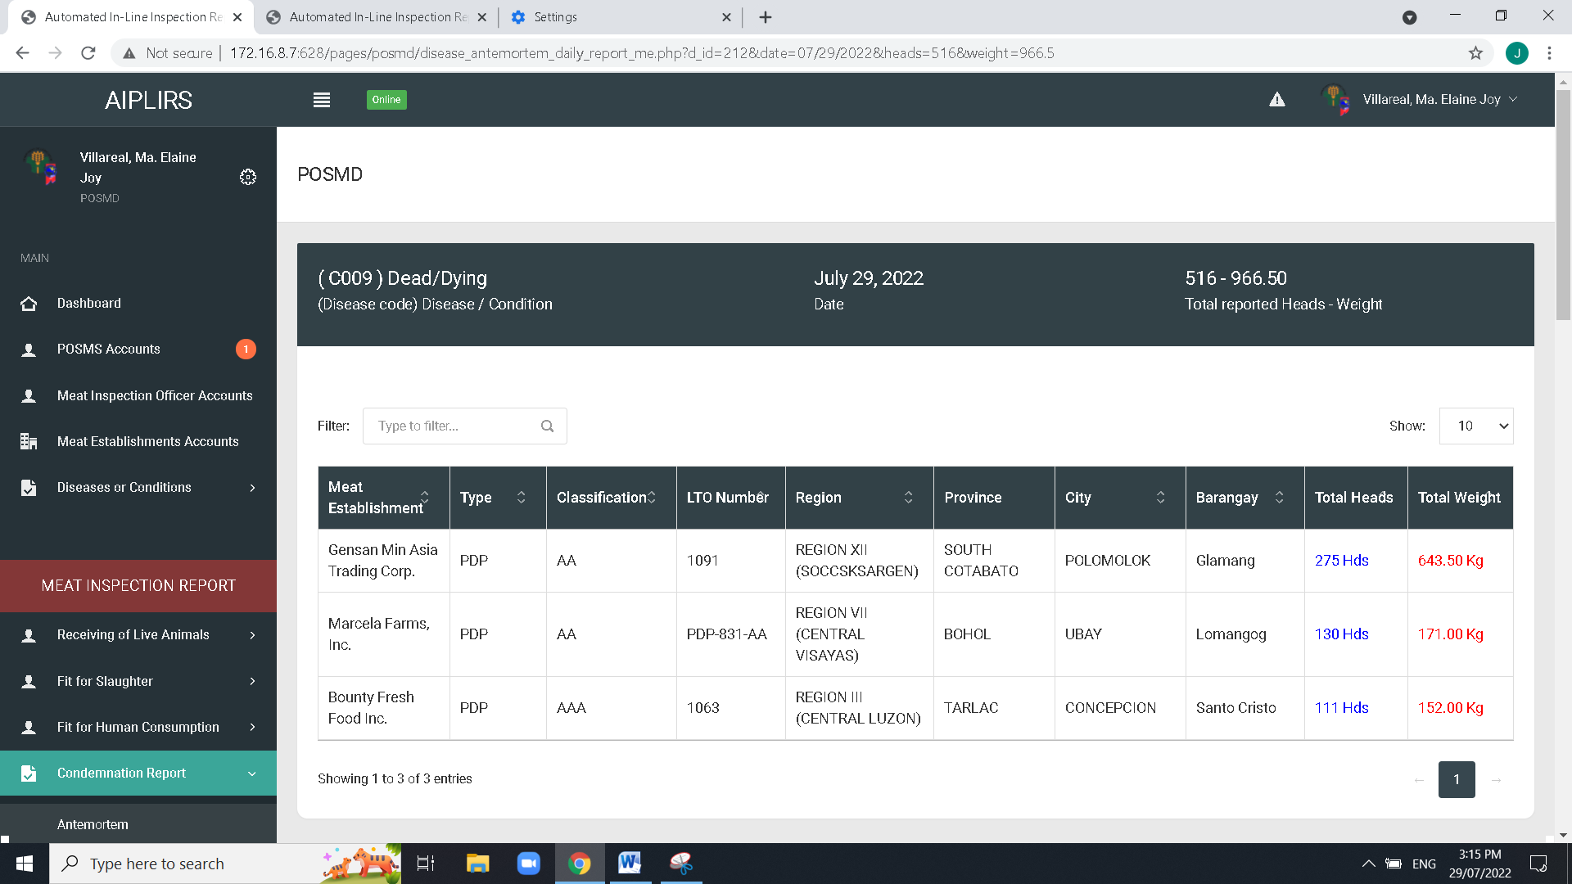

Remove extension in Unit of Measurement same on total heads (both AM- PM)

(both AM- PM)

(both AM- PM) Head Count

small “K” in “kg”

(both AM- PM)Add a filtering dropdown such as:

From - to date, Regional, Provincial, City, Code, Disease / Condition, Species



Make it by column (both AM- PM)

Date range(both AM- PM)

* Total heads - Head count
* Total weight with Unit of measurement
* Remove unit of measurement in data
* (both AM- PM)

Improve user-interface in this row and move title to the top of the data (both AM- PM)

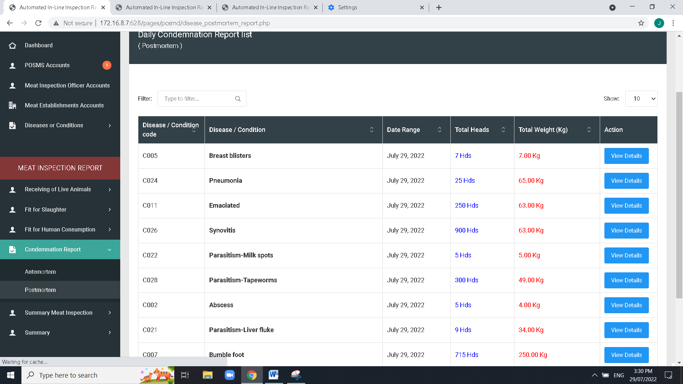

Head count, small “K”

Change to “Code”

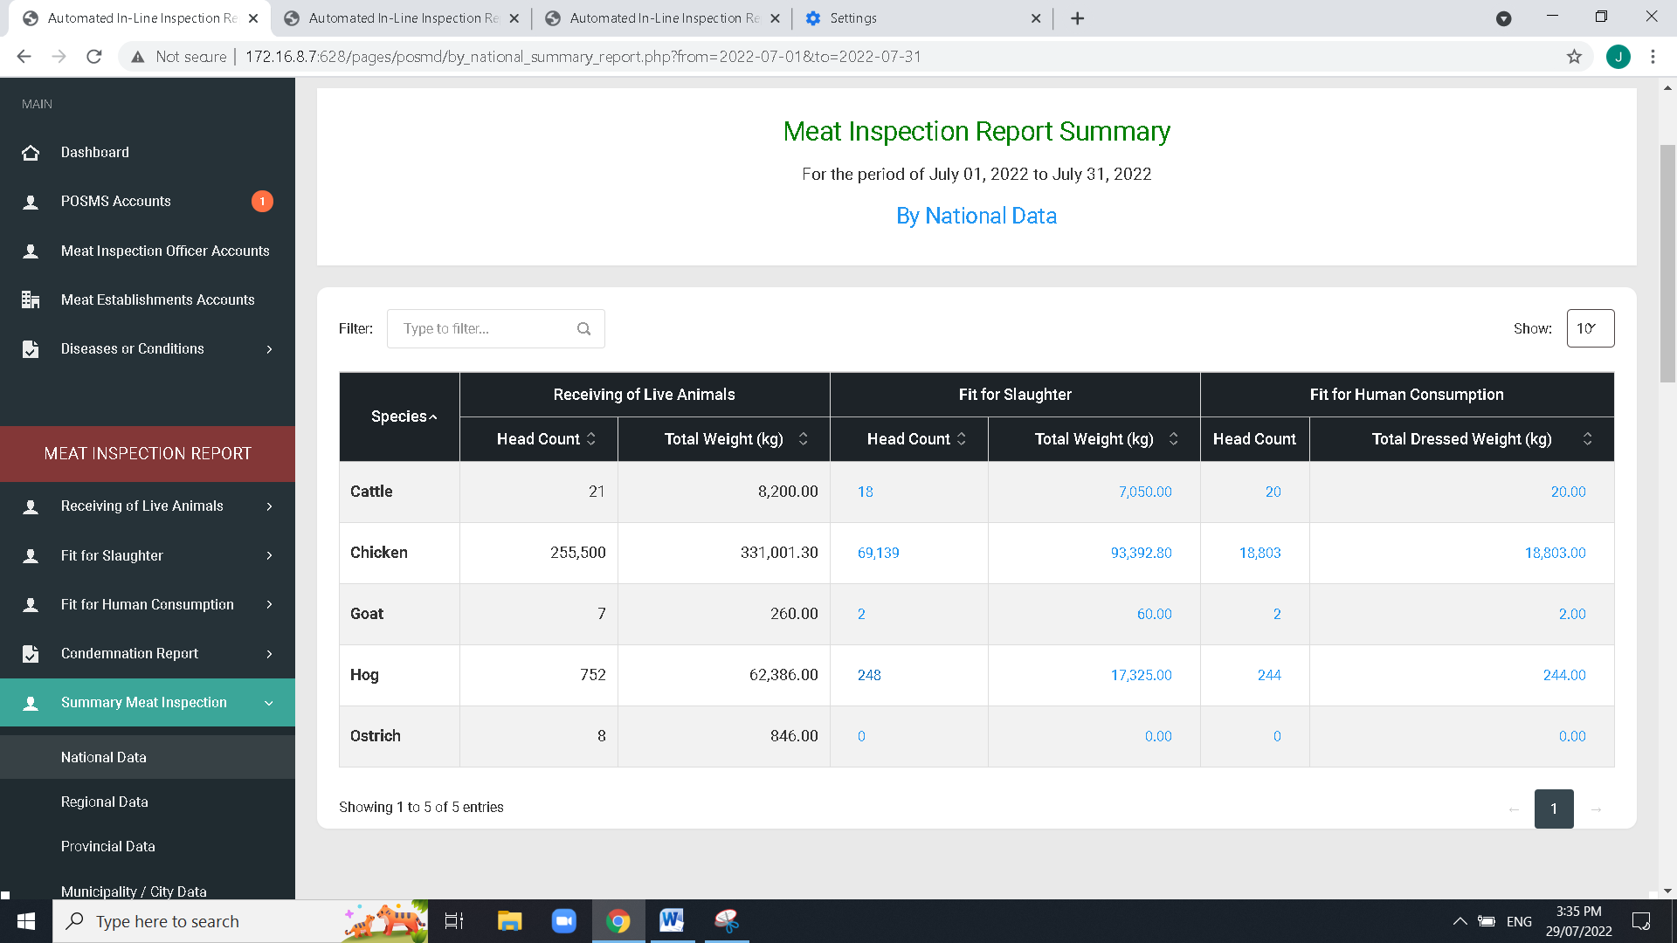

Same issue with the MIO revised on Localhost that the total result is based on head count Instead of total weight

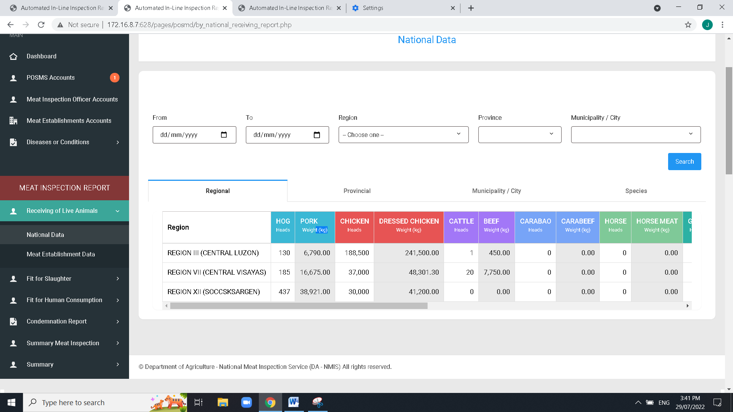

Remove “Summary” due to the similarity on the page of Fit for human consumption (redundant)



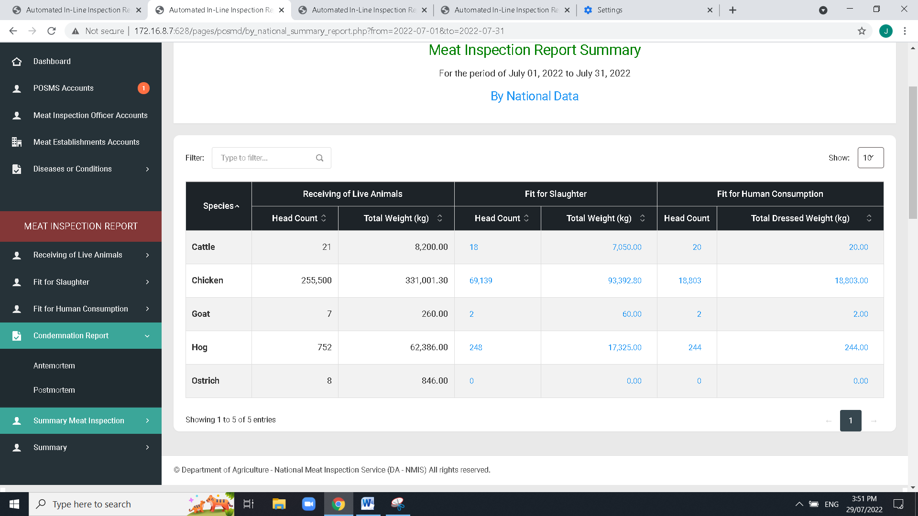

Sidebar label: “Meat Inspection Report Summary”

Add “type of meat”

To think of what user interface to be apply , and filtering dropdows such as: From – to date, Regional, Province, City,Species